**HBase findings and trials**

**Different ways to use HBase**:

HBase is an open source NoSQL distributed database, we don't need a specific schema for the storageFrom our investigation on materials present on HBase, there are different ways we could use HBase in our project: We can

1. Use it locally, by installing it.
2. We can use the AWS EMR HBase service.
3. We can use the plain EC2 instance and install HBase on top of it.

**Using Hbase Locally**:

For local installation we have below options:

* Standalone mode installation (No dependency on Hadoop system)
* Pseudo-Distributed mode installation (Single node Hadoop system + HBase installation)
* Fully Distributed mode installation (MultinodeHadoop environment + HBase installation)

We tried the Standalone installation mode, which require us to follow below steps:

Installation is performed on Ubuntu with Hadoop already installed.

**Step 1)** Place hbase-x.x.x-bin.tar.gz in /home/hduser

**Step 2)** Unzip by executing command $tar -xvf hbase-x.x.x-bin.tar.gz**.** It will unzip the contents, and it will create hbase-x.x.x in the location /home/hduser

**Step 3)** Open hbase-env.sh as below and mention JAVA_HOME path in the location.

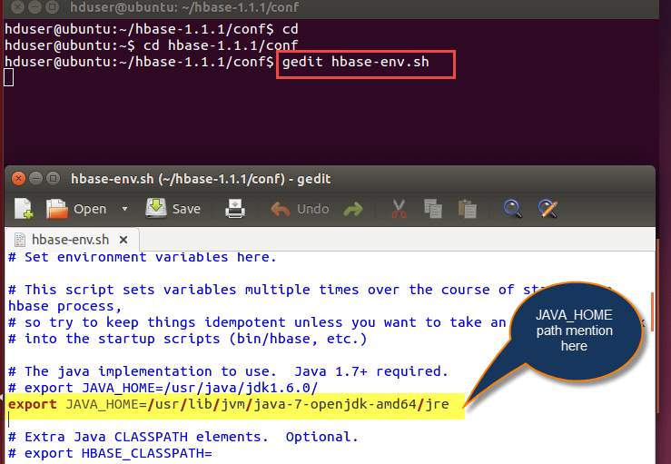

**Step 4)** Open ~/.bashrc file and mention HBASE_HOME path as shown in below

|  |
| --- |
| export HBASE_HOME=/home/hduser/hbase-x.x.x export PATH= $PATH:$HBASE_HOME/bin |

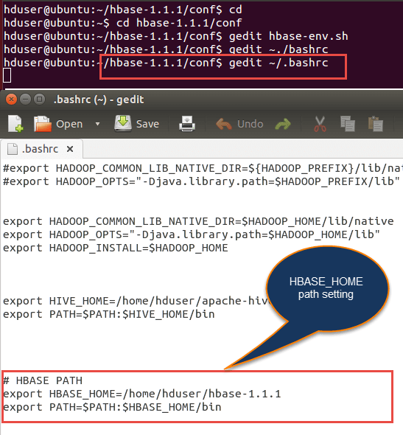

**Step 5)** Open hbase-site.xml and place the following properties inside the file

ubuntu$ gedit hbase-site.xml(code as below)

<property>

<name>hbase.rootdir</name>

<value>file:///home/hduser/HBASE/hbase</value>

</property>

<property>

<name>hbase.zookeeper.property.dataDir</name>

<value>/home/hduser/HBASE/zookeeper</value>

</property>

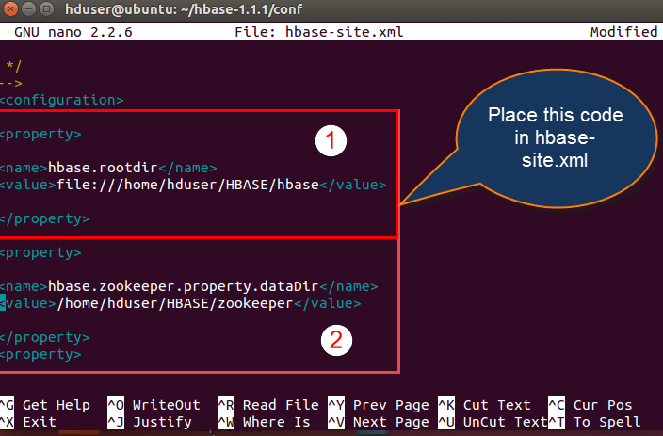

Here we are placing two properties

* One for HBase root directory and
* Second one for the data directory corresponds to ZooKeeper.

All HMaster and ZooKeeper activities point out to this hbase-site.xml.

**Step 6)** Open hosts file present in /etc. location and mention the IPs as shown in below.

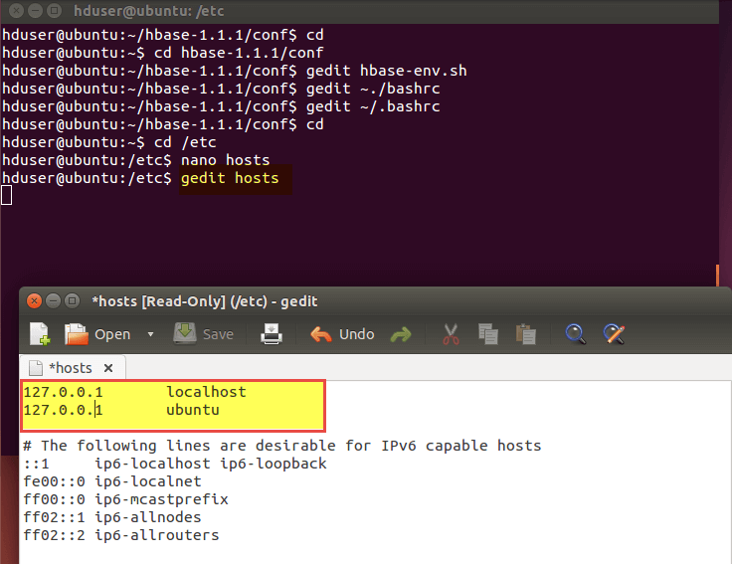

**Step 7)** Now Run Start-hbase.sh in hbase-x.x.x/bin location as shown below.

And we can check by jps command to see whether HMaster is running or not.

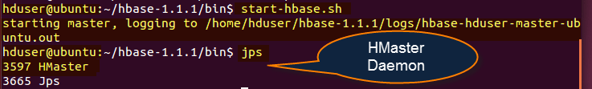

**Step8)** HBase shell can start by using "hbase shell" and it will enter into interactive shell mode as shown in the screenshot below. Once it enters shell mode, we can perform all types of commands.

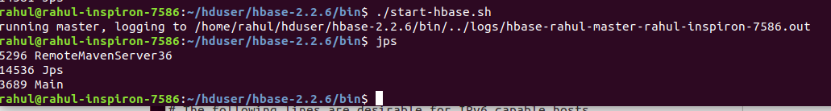

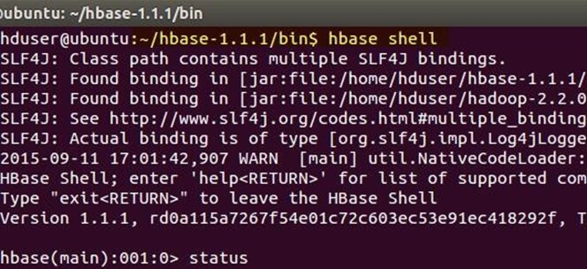

**As it is seen above the standalone mode works fine, but when we try to access it at:** [**http://localhost:60010/**](http://localhost:60010/) **we can’t see the page. We also checked the zookeeper on the port 2181, which is the default mode for the zookeeper installation but it didn’t work.**

**So we assumed it may work in pseudo distributed mode**:

We follow the steps similar to we did in case of standalone installation but changing the distributed property in HBase-site.xml as **true**.

<property>

<name>hbase.cluster.distributed</name>

<value>true</value>

</property>

Now we point to our hadoop installation and start Hadoop daemons first and after that start HBase daemons as shown below:

Here first you have to start Hadoop daemons by using**"./start-all.sh"** command as below.

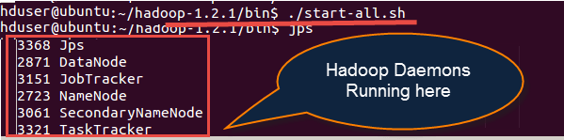

After starting Hbase daemons by hbase-start.sh

How to Download & Install Hbase

Checking **jps**

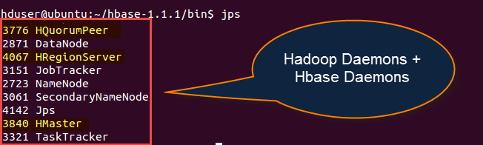

As we see the all the above steps worked perfectly fine but still we were not able to expose the hbase via zookeeper on port 2181, we followed different articles on stack overflow, blogs but didn’t find something meaningful that could solve this issue. While following the above steps we encountered many errors but were able to solve them and reach the above steps at the end.

We also tried following steps mentioned in the blog: <https://www.tutorialspoint.com/hbase/hbase_installation.htm>

But we encountered many errors and were not able to expose the port and access it from our java application.

**After not being able to make the above steps work, we thought of leveraging the managed HBase service from AWS which comes with AWS EMR**:

We followed the blog: <https://aws.amazon.com/emr/features/hbase/> and tried following the configuration from the UI as mentioned in the post: <https://docs.aws.amazon.com/emr/latest/ReleaseGuide/emr-hbase-configure.html>

We created an EMR cluster with HBase installed as seen below:

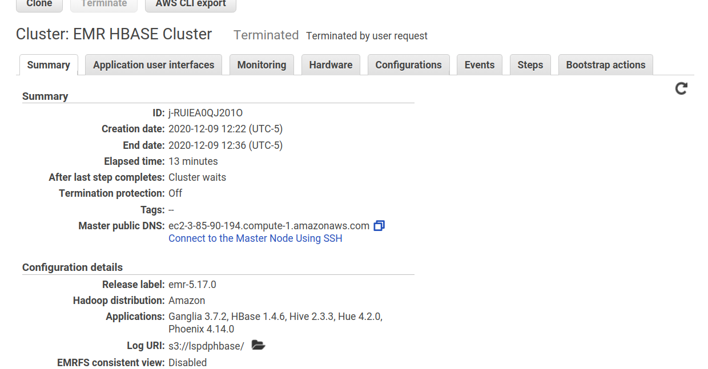

And tried accessing the cluster on [http://*master-public-dns-name*:16010/](http://master-public-dns-name:16010/) for the HBase service. <https://docs.aws.amazon.com/emr/latest/ManagementGuide/emr-web-interfaces.html>

But here as well we were unable to access the HBase via port 16010 or zookeeper 2181. Working on this has already consumed a significant portion of time hence we dropped the plan to further get hbase working, we could have installed it on a plain EC2 instance and get it working but as the local installation didn’t work and we were not able to expose the port **2181** or **16010.**

**Hence as a suggestion from the professor we opted for broadcasting the HBase data during the MapReduce jobs.**